The panpipes were one of the instruments considered. They consist of 15 pipes and notes would be played by blowing air across the openings of the pipes. According to research done in [1], the pipes would require about 8.5 litres per minute [1] of airflow to play notes the octaves above C6 (if C1 is the first C).

Research was done on other wind instruments such as the Waseda Flutist Robot [2] but due to the complexity of some components such as the artificial lips and lungs this was considered an unfeasible option due to the time constraints of the project. Another example of a wind instrument was the Saxophone Playing Robot [3] but that too required complex moving parts mentioned before.

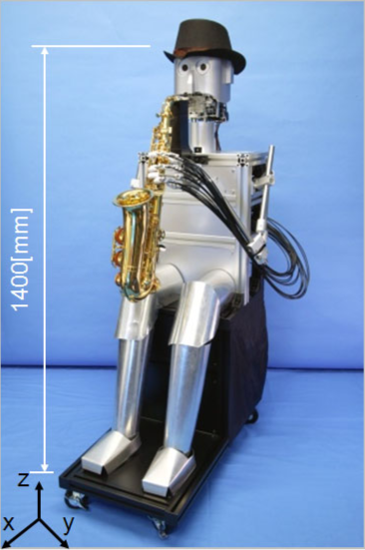

Figure 1.1b. Saxophone Playing Robot [3].

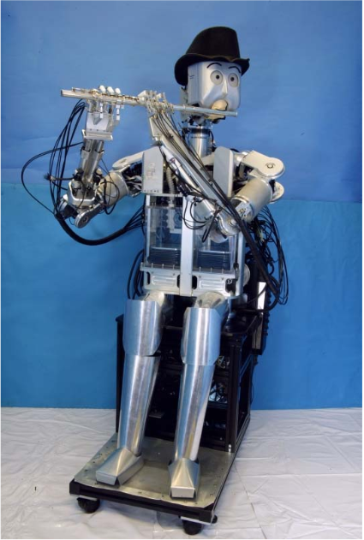

Figure 1.1a. Waseda Flutist Robot [2].

Proof of concept can be seen in video [4] where a set of panpipes is being played by a robot that moves the panpipes across a nozzle that blows air across the pipes producing the corresponding notes.



Figure 1.2. Panpipe playing Robot [4].

The panpipes are easier to automate since there are less moving parts and Degrees of Freedom (D.o.F) involved compared to the other wind instruments. The panpipes were therefore the preferred instrument due its simplicity and range of notes.

Guitar

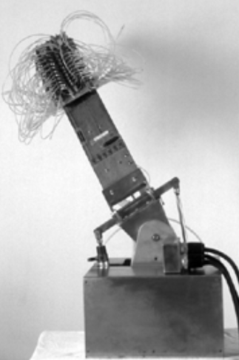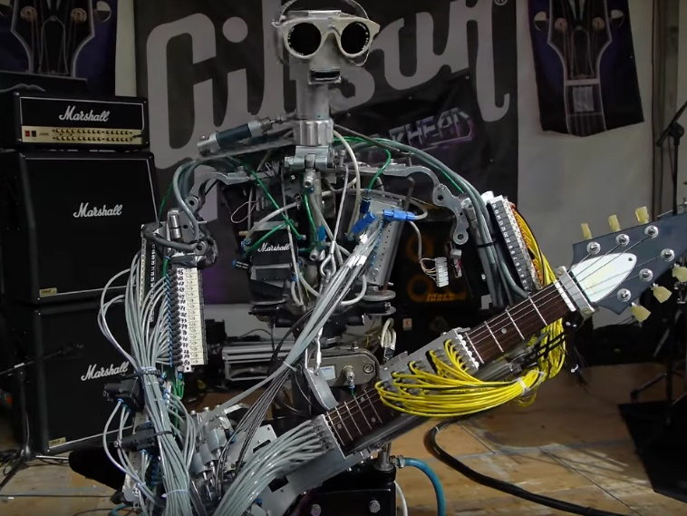The guitar was another instrument that briefly researched as a potential instrument. There are few research papers on 6-stringed guitars therefore videos were the primary source of analysis. A paper on the history of robot instruments [5] shows a guitar with “72 finger left hand”[5], and a video of Compressorhead preforming the *Ace of Spades* [6].

Figure 1.1. Sergi Jorda’s Afasia from [5].

Figure 1.2. Compresorheads 6-String guitar robot preforming *Ace of Spades* [6].

Both robots have a relatively simple plucking system but a complex fret mechanism consisting of multiple solenoids or other moving parts which could be well take up a large portion of the budget and time which needs to be given to other instruments. This instrument was later discarded due to these reasons.

# References

[1] <http://www.conservationphysics.org/flute/flute.php>

[2] <https://ieeexplore.ieee.org/stamp/stamp.jsp?tp=&arnumber=4543771>

[3] https://link.springer.com/chapter/10.1007/978-3-642-16259-6_14

[4] T. Dare, "TeamDARE's robot band plays 'Rolling in the deep'," TeamDare, 27 August 2011. [Online]. Available: https://www.youtube.com/watch?v=RKpKygGX2Nk [Accessed November 2017].

[5] <http://www.music.mcgill.ca/~ich/research/misc/papers/cr1264.pdf>

[6] <https://www.youtube.com/watch?v=xP4sYKR4NUc>